CalcApp — IS601 Final Project
Kundan Singh
Spring 2026
- 🔗 GitHub: https://github.com/KKS071/is601-final-extended-calculator-suite
- 🐳 Docker Hub: https://hub.docker.com/r/kks59/is601-final-extended-calculator-suite
- Reflection Document is added under the “docs” folder in project root.

GitHub Actions Screenshot:
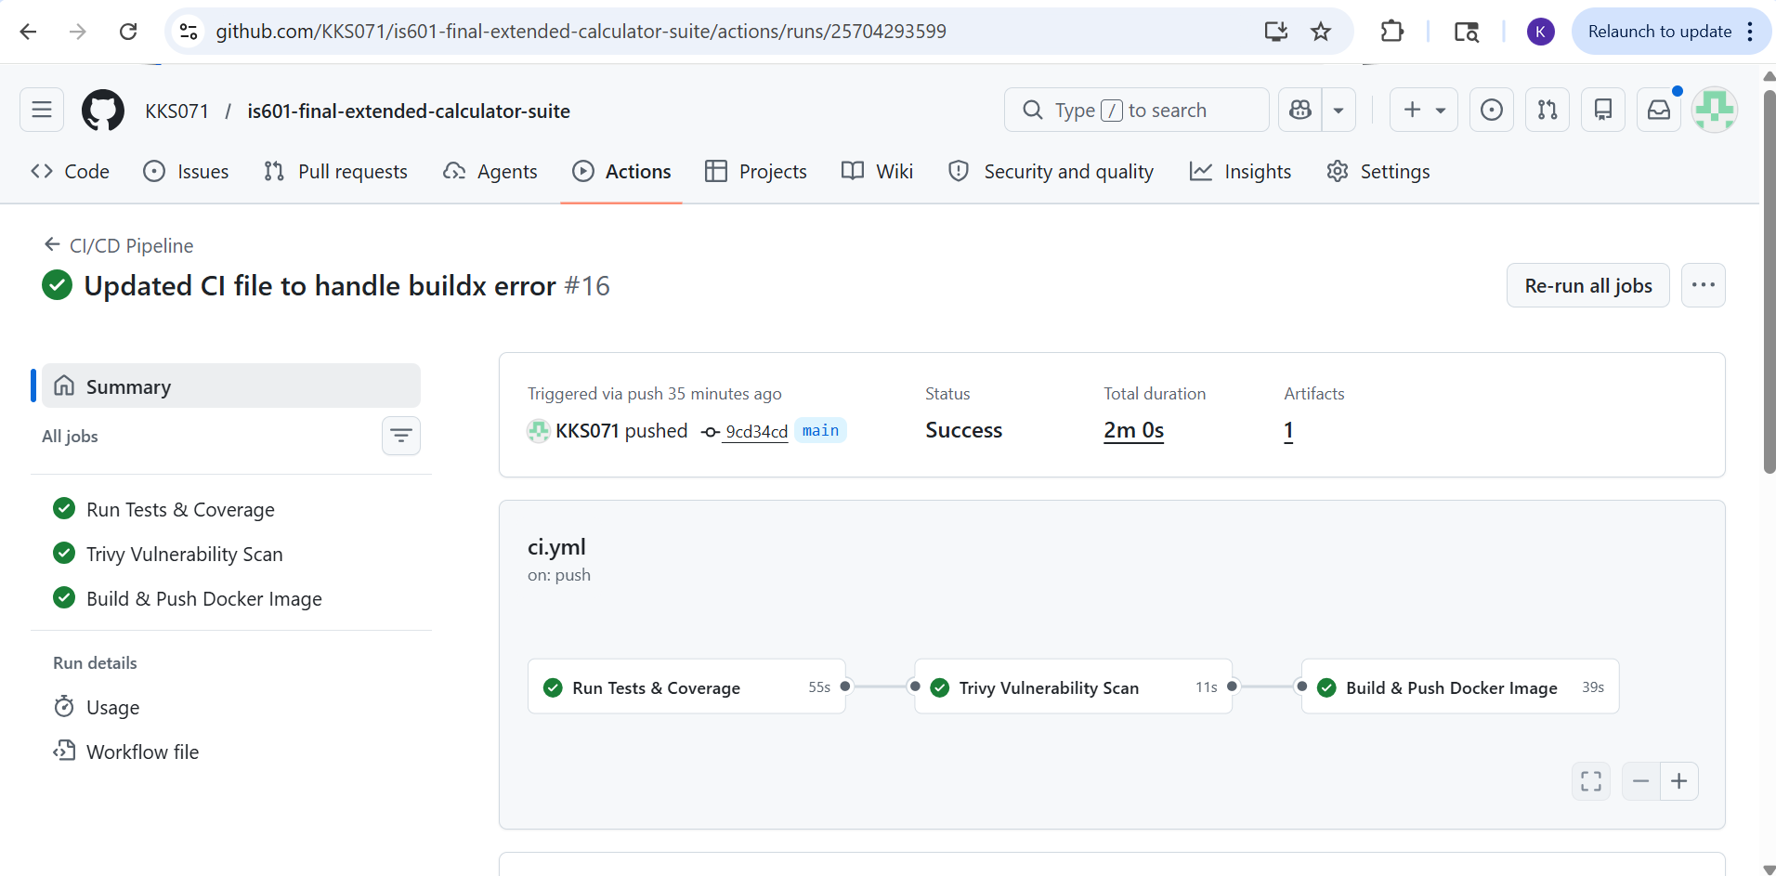

Docker Hub Screenshot:
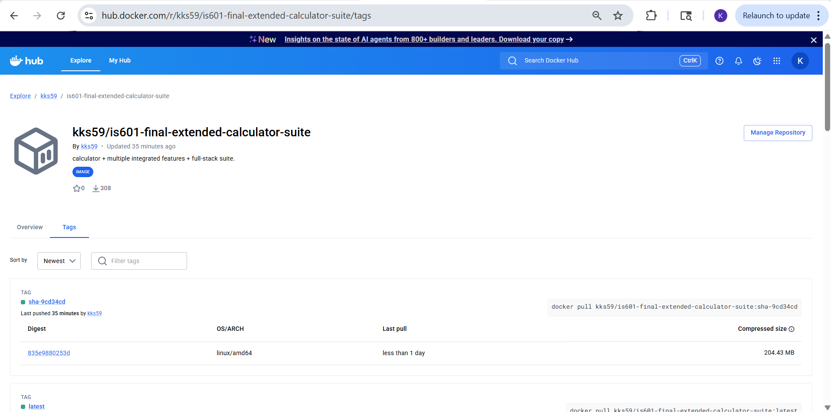

Pytest Result with 100% coverage:
